**INDUSTRIAL TRAINING REPORT**

**at**

**DELOITTE CONSULTING MALAYSIA**

**NUR SYAZWANI BINTI SAMSAWI**

**2022876358**

REPORT

**College of Computing, Informatics and Mathematics**



|  |
| --- |
| **UNIVERSITI TEKNOLOGI MARA** |

|  |
| --- |
| **INDUSTRIAL TRAINING REPORT** |

At

|  |
| --- |
| **Menara LGB, Level 7, Jalan Wan Kadir, Taman Tun Dr Ismail, 60000 Kuala Lumpur**  **3 months** |

|  |
| --- |
| **NUR SYAZWANI BINTI SAMSAWI**  **2022876358** |

|  |
| --- |
| **Report submitted on partial fulfillment of the requirement** |
| **for the degree of** |
| **Bachelor of Computer Science (Hons.) Multimedia Computing** |

|  |
| --- |
| **College of Computing Informatics and Mathematics** |

|  |
| --- |
| **JULY 2024** |

Approved by:

|  |  |  |
| --- | --- | --- |
| Name | : | Dr. Norizan Binti Mat Diah |
| Department | : | Computing Sciences (College of Computing Informatics and Mathematics) |
| Signature | : |  |
| Date | : |  |

ACKNOWLEDGEMENTS

|  |
| --- |
| First and foremost, Alhamdulillah. I would like to express my deepest gratitude to the Almighty God for blessing me with good health, a conducive work environment, and for easing my path in completing all the tasks and projects assigned by the company. I am especially grateful for being surrounded by wonderful people who have supported me throughout this journey.  Moreover, I could not have completed this report without the invaluable guidance of my academic supervisor, Dr. Norizan Binti Mat Diah. She has been exceptionally supportive of both me and my colleague, not only in the preparation of this report but also by providing moral support. She is always ready to lend a helping hand and goes above and beyond to assist us whenever needed.  I would also like to thank my industry supervisor, Mr. Goh Yuen Fei, as well as Senior Manager Mr. Deepak Hiremath, Head of the ICDC Department Mr. Andrew, and all the Deloitte ICDC staff for wholeheartedly welcoming me to undergo my practical training at the company. They generously dedicated their time and resources to guide and train me to the best of their ability.  Next, I extend my gratitude to UiTM for including CST688 in our study plan. This course provides students with the opportunity to experience a real-world working environment and enhances both our soft and technical skills. It has broadened my horizons and shifted my perspectives on various aspects of life.  Finally, I want to express how blessed I feel to have the unwavering support of my family, an amazing group of friends, and very helpful colleagues. Their endless support, assistance, and encouragement, both directly and indirectly, have been instrumental throughout this journey. With this incredible support system, I was able to successfully complete this report without significant complications.  Date: Name: Nur Syazwani Binti Samsawi |

# TABLE OF CONTENTS

**Page**

ACKNOWLEDGEMENTS iv

TABLE OF CONTENTS v

LIST OF TABLES vi

LIST OF FIGURES vii

CHAPTER 1 : INTRODUCTION 1

1.1 Background of Industrial Training 1

1.2 Background of Organization 1

1.3 Background of Department Attached 2

CHAPTER 2 : ASSIGNMENTS 3

2.1 Technical Learning Path 3

2.1.1 Introduction 3

2.1.2 Implementation 3

2.1.3 Results and Discussion 4

2.2 Pair Project (Ticketing Support System) 5

2.2.1 Introduction 5

2.2.2 Implementation 6

2.2.3 Results and Discussion 9

CHAPTER 3 : CONCLUSION AND RECOMMENDATIONS 10

3.1 Benefit of the assignments 10

3.2 Summary of Industrial Training 11

APPENDICES 12

# LIST OF TABLES

**Page**

Table 1.1 General Information of Organization 2

Table 2.1 Project Scope 5

# LIST OF FIGURES

**Page**

Figure 2.1 Technical Learning Path Stream 4

Figure 2.2 Deloitte's ServiceNow System Dashboard 6

Figure 2.3 Initial Dexter Entity Relationship Diagram 7

Figure 2.4 Project Directory Arrangement via Visual Studio Code 7

Figure 2.5 Docker Hub Repository for Project Deployment 8

Figure 2.6 GitHub Repository for Project Deployment 8

# INTRODUCTION

## Background of Industrial Training

Computing Science Industrial Training (CST688) is the industrial attachment program that is mandatory for all computer science UiTM students during their final semester. Students must undergo an internship at an approved organization after completing all courses for a period of three months. This industrial training course is an integral part of the related program curriculum, enabling students to experience a structured, supervised learning environment that enhances the knowledge gained in previous courses, combining the program syllabus and real-world applications. At the end of this course, students are required to submit a report and logbook on the work that has been done.

## Background of Organization

Deloitte is a leading global provider of audit and assurance, consulting, financial advisory, risk advisory, tax, and related services. Founded in 1845 by William Welch Deloitte in London, United Kingdom, Deloitte now operates through over 150 countries, employing 400,000 professionals worldwide, and that includes Malaysia. Deloitte Malaysia started operating in 1968 and offers a wide range of solutions catered to meet the local market’s needs. The headquarters is in Kuala Lumpur with several regional offices based in Pulau Pinang, Johor Bharu, Ipoh, Kuching and Kota Kinabalu.

Although Deloitte is widely known for its audit and tax related services, they have significantly expanded their expertise into technology and innovation, especially in their consulting and risk advisory divisions. This includes areas such as digital transformation, emerging technologies, cybersecurity, artificial intelligence, etc. Moreover, Deloitte also has immensely invested in research and development (R&D) to stay ahead in providing technology driven solutions to clients mainly in the tech industry and employs thousands of technology professionals all over the globe such as data scientists, software engineers and AI specialists.

In Deloitte Malaysia, these technological solutions are generated from the Innovation and Cloud Development Centre (ICDC) which is the department I am assigned to.

## Background of Department Attached

The Innovation & Cloud Development Centre (ICDC) at Deloitte focuses on driving digital transformation and innovation by integrating cloud technologies and software development. The department operates as a hub for creating technology-abled solutions catered to clients' business needs. ICDC teams typically handle tasks such as designing and developing software, implementing cloud-based solutions, and delivering digital architecture for a variety of industries.

In Malaysia, roles within ICDC include developing middle-tier and back-end solutions, working on system integrations, and contributing to innovative digital tools. The department also supports clients by providing technical expertise in platforms like Salesforce and Out systems while using frameworks such as Java and Spring Boot for development. Their approach combines technical innovation with business strategy to create solutions that solve complex challenges in sectors such as healthcare, customer relations, enterprise performance​, and so on.

Table . General Information of Organization

|  |  |
| --- | --- |
| Name | Deloitte Malaysia |
| Branch | Kuala Lumpur (Malaysia Headquarters) |
| Department | Innovation & Cloud Development Centre (ICDC) |
| Vision and Mission | We aspire to be the Standard of Excellence, the first choice of the most sought-after clients and talent.  to help our clients and people excel. |
| Operating Hours | 8.30 am – 5.30 pm |
| Location | Menara LGB, Level 7, Jalan Wan Kadir, Taman Tun Dr Ismail, 60000 Kuala Lumpur |
| Contact number | 03-7610 8888 |
| Website URL | https://www2.deloitte.com/my/en.html |

# ASSIGNMENTS

## Technical Learning Path

The technical learning path consists of self-learning sessions on front-end and back-end technology using provided learning materials on Udemy.

### Introduction

During the first month of internship, technology interns were required to undergo self-learning sessions focused on both front-end and back-end technologies. For the front-end learning path, I completed the React JS learning course on Udemy while for the back-end I took two courses. The first course was on application environments, specifically Docker, and the second course focused on back-end frameworks, covering Spring Boot microservices.

### Implementation

The first course I completed for the technical learning path task was on React JS titled *“Master React and Redux. Apply modern design patterns to build apps with React Router, Tailwind CSS, Context, and Hooks!”* which includes hands-on activities such as building simple projects and troubleshooting common errors. This course also provides explanations of key concepts and theories surrounding ReactJS, along with helpful libraries commonly used in React.

The second course I took was on back-end application environment, specifically Docker, a service for project containerization and deployment. For Docker, I watched two courses on Udemy to grasp the concept better. These courses also explained in detail the concept and benefits of using Docker. The courses include frequent hands-on sessions, such as practicing commands for building images, running containers, deploying images, and basic housekeeping.

The last course I undertook was on Spring Boot, a framework used for building Java-based web applications and microservices. This learning course provided comprehensive explanation of the key components that are crucial for building a RESTful web application. This course consists mostly of hands-on activities which include HTTP response validation, authentication, JWT token, and more.

### Results and Discussion

In the first course, I learned how to build basic React projects, including the common structure, and handling navigation using react-route-dom. I also explored react hooks and contexts for functionality, using useEffect, useCallback and useState. Additionally, I learned how to persist data using Json storage and use Json dummy database for application testing. In terms of UI design, I learned how to style using Tailwind CSS and Shadcn/ui which significantly optimized the development process.

In the second course, I focused on deploying and containerizing projects using Docker. However, due to device compatibility issues, I used Podman as an alternative. Learning Docker was challenging because it introduced entirely new concepts and services that I had not encountered during my studies. Despite the initial difficulty, Docker helps optimizing deployments, standardizing versions across platforms, and enhancing scalability.

In the Spring Boot learning course, my understanding of Java-based projects has improved as many of the concepts aligned with JavaBeans, which I studied in Enterprise Programming (CSC584). This course has enhanced my knowledge of how HTTP response work and how it is secured over the web. However, I faced recurring problems during the hands-on sessions due to the deprecation of several libraries and conflicting versions.

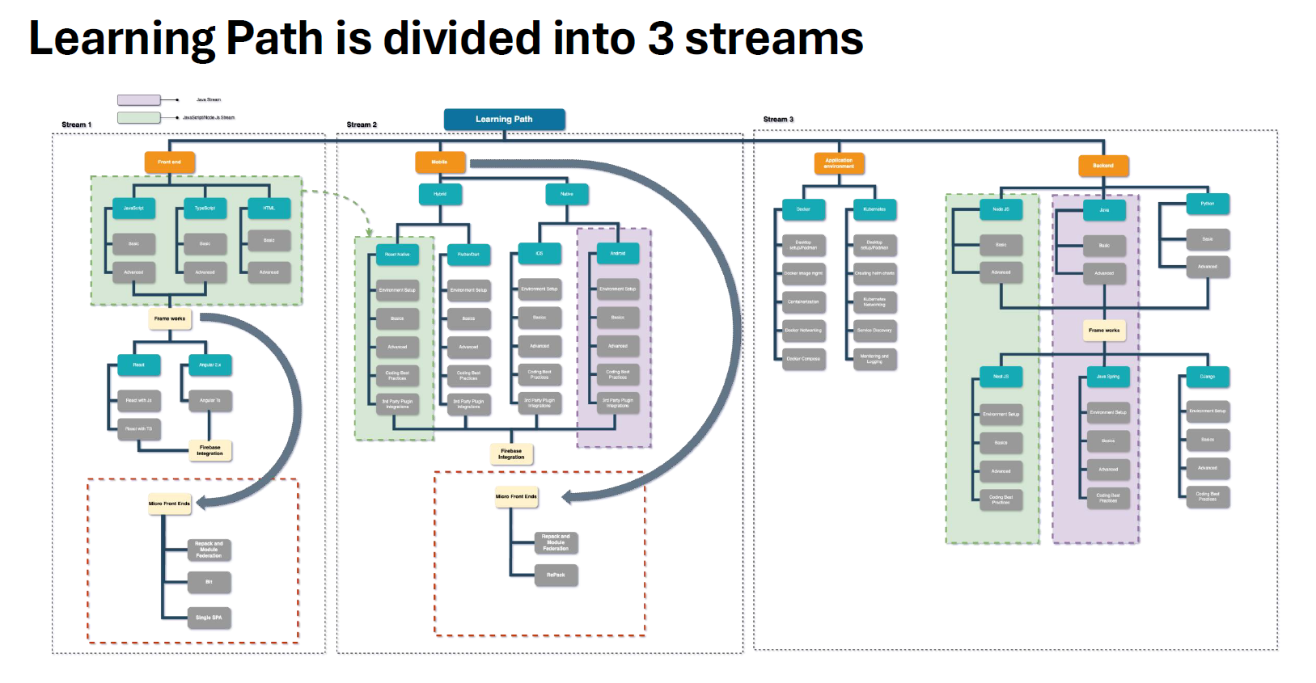

Figure . Technical Learning Path Stream

## Pair Project (Ticketing Support System)

Upon completing the technical learning path, our project manager, Mr. Deepak, assigned us a pair project. My team decided to develop a ticketing support system to facilitate interaction between users and support agents via ticket management and tracking. We named the system “Dexter”.

### Introduction

“Dexter” is a ticketing support system designed to manage tickets created by users, allows agents to manipulate tickets, and facilitate interaction between users and support agents. This project was developed with reference to Deloitte’s ServiceNow System, a ticketing support system platform at Deloitte. The project incorporates several technologies that we have learned during the previous technical learning path. For the front-end framework, we decided to use React JS with Vite. For the UI styling, we settled with Tailwind CSS and Shadcn/ui components, and Supabase as our back-end database. For CI/CD pipeline, we utilized GitHub repository service for easier collaboration. Lastly, we containerized the project using Podman. The scope of this project covers three types of users, which are the administrator, support agents, and end users.

Table . Project Scope

|  |  |
| --- | --- |
| Type of users | Scope |
| Administrator | * Create new accounts for employees * Assign roles to employees (users and agents) |
| Support agent | * Pick new ticket and become the assigned agent * Update ticket status and read ticket details * Send message to ticket owner (user) * Receive notification on new ticket and user’s message |
| End user | * Creating a new ticket * Track ticket status and read ticket details * Send message to assigned agent * Receive notification on ticket updates and message from support agents |

### Implementation

For the implementation, we followed the standard Software Development Life Cycle (SDLC), which includes the planning, design, implementation, and deployment phases, to ensure a consistent and structured project completion process.

**Planning Phase**

In the planning phase, we identified the required functionalities and defined the scope of actions for each user type. This involved gathering and analyzing the user requirements. During this phase, we mostly referred to Deloitte’s ServiceNow system and its functionalities for guidance.

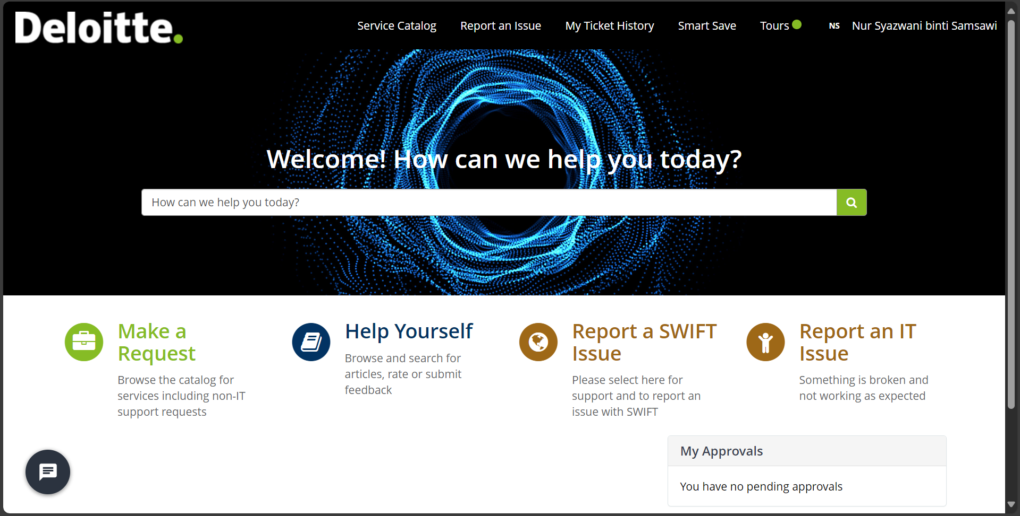

Figure . Deloitte's ServiceNow System Dashboard

**Design Phase**

Next, we began by designing the back end and database structure using an Entity-Relationship Diagram (ERD). The initial ERD included 7 tables which are agents, agents_ticket, users, users_ticket, tickets, ticket_status, and message. After implementing research on Supabase’s architecture and services, we simplified the database to 6 tables which are user_roles, agent, users, tickets, status, and ticket_history. Nonetheless, the finalized database structure still retained elements of the initial ERD made during this phase. We also proceeded to design the user interface for both the support agents and end users to ensure the necessary functionalities are presented in a presentable and intuitive manner.

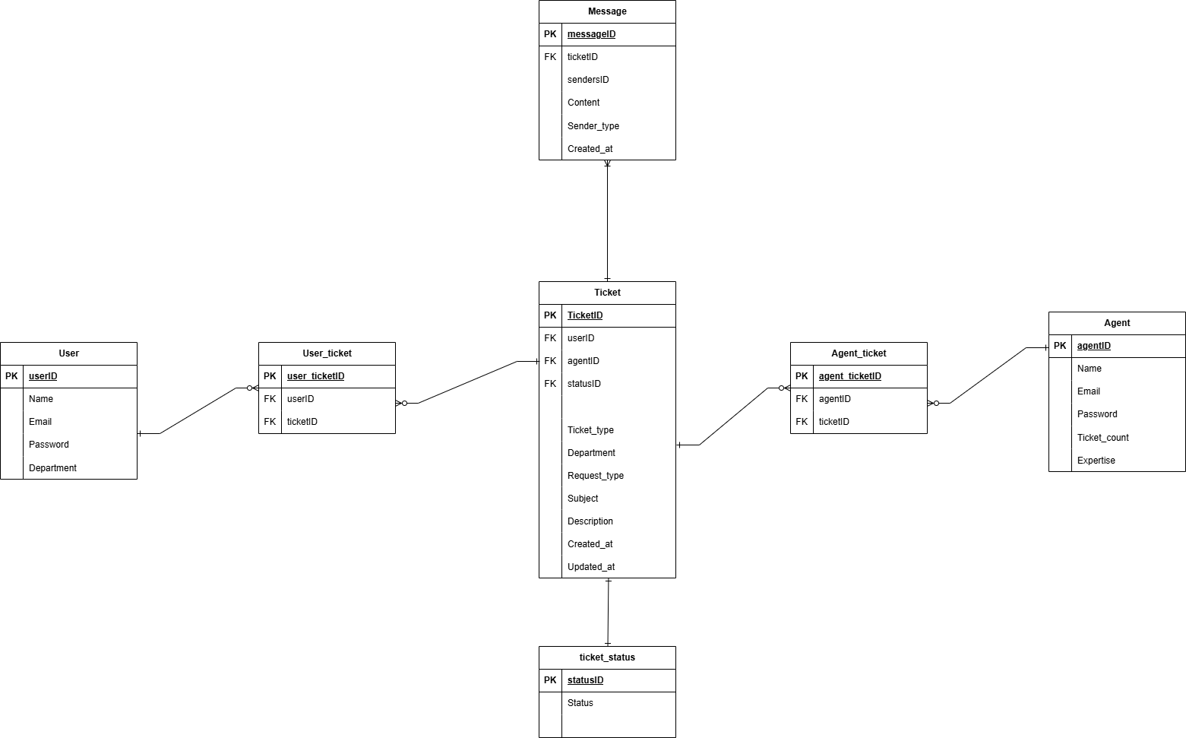

Figure . Initial Dexter Entity Relationship Diagram

**Development Phase and Testing Phase**

Once the design phase was completed, we began developing the application using React + Vite framework. We carefully organized the project directory systematically, defining necessary hooks and context as well as reusable components. These contexts were also used for integrating the application with the back-end database (Supabase) as well as subscribing to back-end services such as authentication and real-time integration. The testing of this project was conducted frequently in between component development upon bug detection.

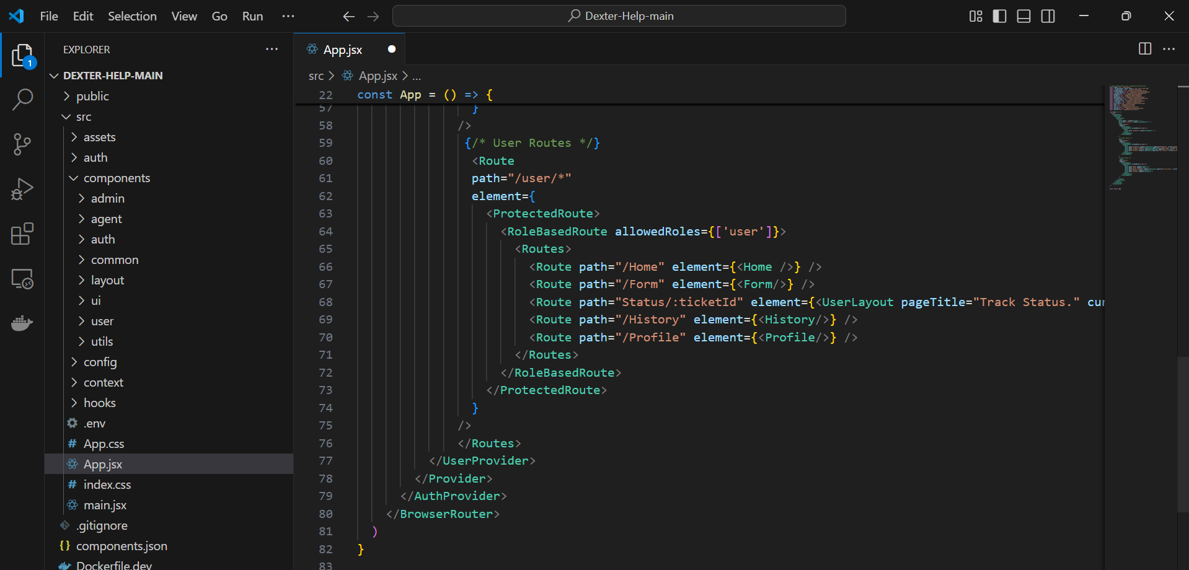

Figure . Project Directory Arrangement via Visual Studio Code

**Deployment Phase**

At this stage, the application and its functionalities have been finalized and fine-tuned. We began by containerizing the application by creating a Dockerfile within the project directory, building an image from the application using Podman, and pushing the image to DockerHub for deployment. The image was then used to run a container of the application.

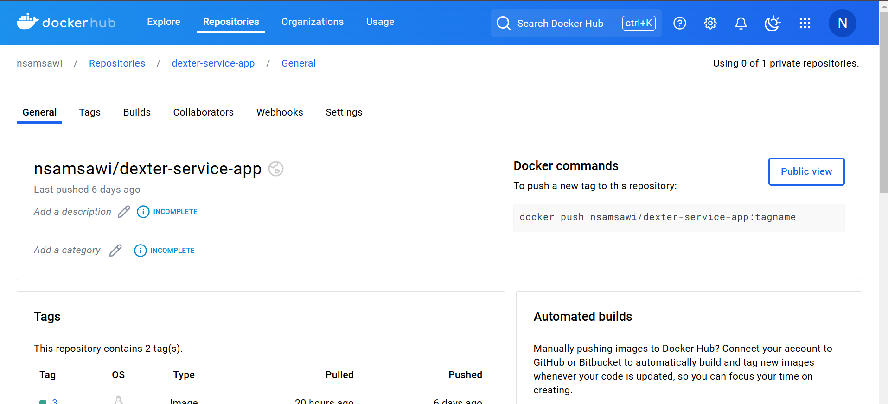

Figure . Docker Hub Repository for Project Deployment

Additionally, the project was uploaded to GitHub to establish the CI/CD pipeline which automates the build, test, and deployment processes. By hosting the project to GitHub, version control and collaboration features are obtained and ensure that any future updates are thoroughly tested and seamlessly deployed to the production environment.

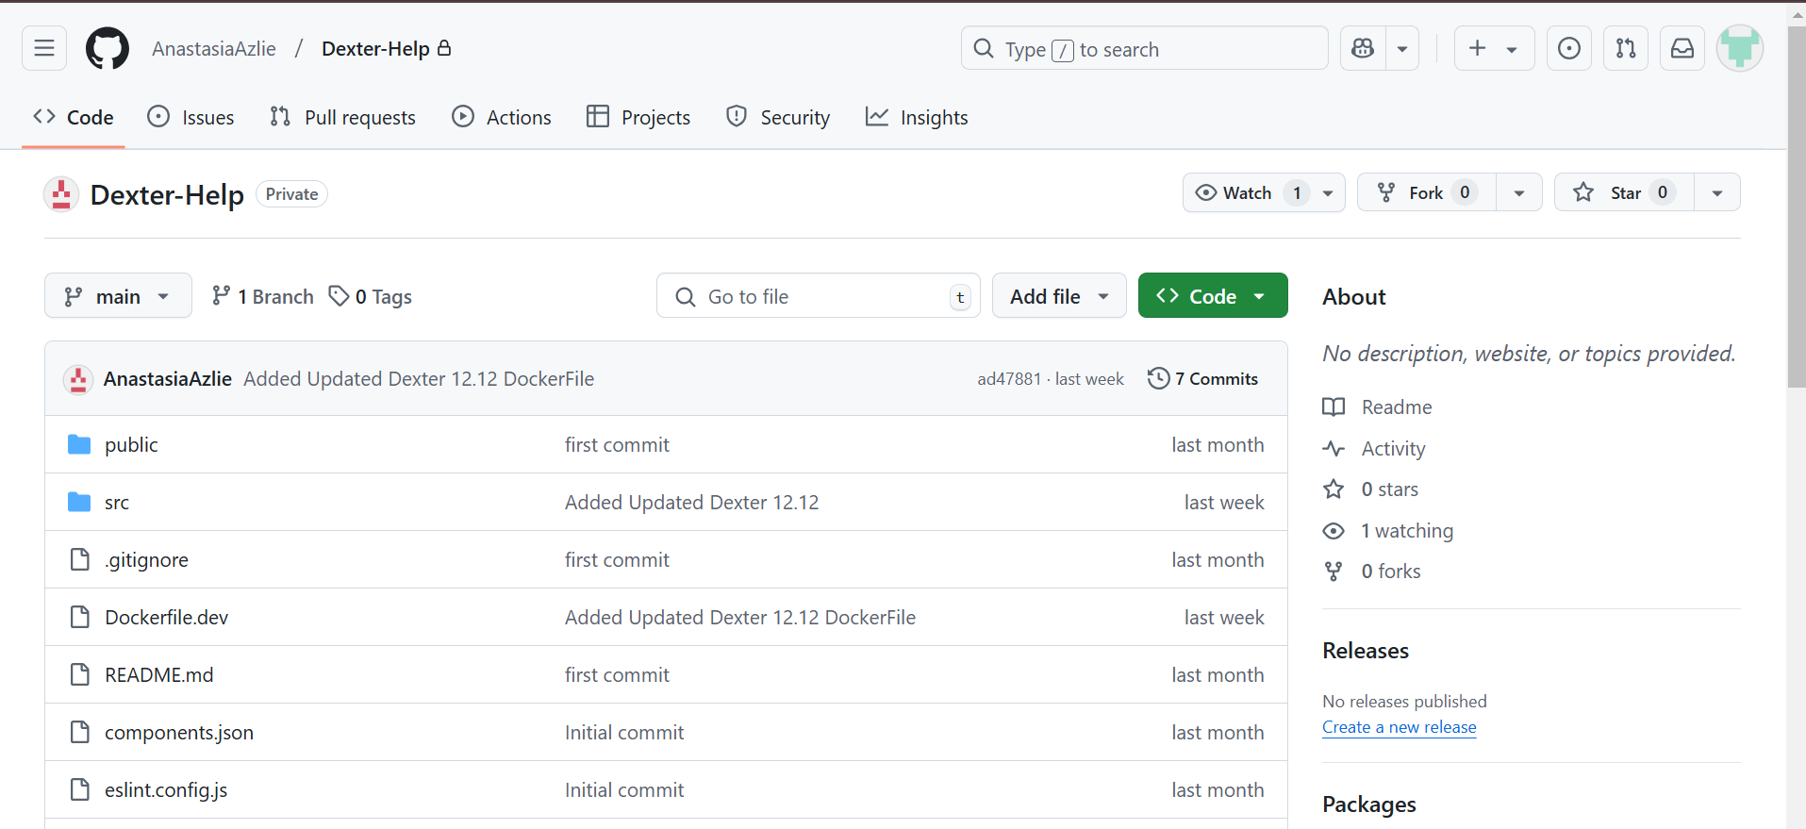

Figure . GitHub Repository for Project Deployment

### Results and Discussion

The ticketing support system development was completed within the designated timeframe and successfully met all the user requirements including additional features for better user experience. The support system consists of a simple dashboard for the administrator to create accounts for employees. The administrator will assign a role to them (Support agent or user). Thus, only accounts registered by the administrator can log into the system.

The support system allows end users to create tickets via a form. Once they submit the ticket, a success box will pop up, notifying the user that their ticket has successfully been inserted into the database. Users can monitor the number of active tickets, pending tickets and closed tickets of their own. They can also view the details of the ticket and track the status of the ticket in real time. They can interact with the support agent by sending messages in the same track status timeline. Even after a ticket is closed, they can still view the ticket details and track status timeline in the ticket history page.

Support Agents can view new tickets and select any ticket to be assigned to them. A confirmation box will pop up when the agent selects a ticket and will be assigned to the ticket only upon confirmation. Once assigned, they can view the ticket details and update the status of the ticket. These status updates will be reflected on the users’ side in real time. Agents can also interact with users by sending messages in the same track status timeline. The Agent can manage the tickets by filtering them by status and ticket type (request or report). They can also monitor the number of active, pending and closed tickets assigned to them.

Additional features of the system include profile update features where users and agents can edit their profile picture, username and bio. Moreover, the system comes with a notification functionality where users are notified of their ticket updates and any message from the assigned agents while support agents will be notified of new tickets inserted, and messages from the owner of the assigned tickets. Lastly, we implemented custom dark mode UI and default mode UI to accommodate diverse preferences using Tailwind CSS.

# CONCLUSION AND RECOMMENDATIONS

## Benefit of the assignments

The assignments and tasks assigned to me during this internship have been incredibly valuable, offering me with a wealth of new knowledge, particularly in the field of computer science and emerging technologies.

**Technical Learning Path**

The technical learning path was an invaluable stepping stone for me to learn and utilize new technologies in a short period of time. Through this task, I managed to learn how to create a React project, conduct styling using Tailwind CSS, dockerize projects for deployment optimization and manage microservices using Spring Boot. Additionally, this session eased the process of implementing the pair project since we used frameworks learned during the technical learning path for the project development. This path also challenged my ability to focus and persevere through persisting errors and problems. However, I do believe that the session has room for improvement. For future technology interns at Deloitte, they should be given more choices of learning materials and more collaborative activities. This can lead to a more technically diverse team of interns.

**Pair Project (Ticketing Support System)**

This pair project gave me a remarkable experience with using new technologies and served as a platform for me to test my knowledge and skills that I’ve polished throughout my study period as well as the technical learning path. During this project, I managed to surpass my concern of trying and experimenting with new technological services and the result exceeded my expectations. Moreover, this task boosts my problem-solving skills since we need to come up with logical solutions when building the functionalities and upon encountering complex errors or bugs. I also managed to use reusable logic and components which enhance the efficiency of the project’s development process. Aside from technical benefits, I also had the opportunity to sharpen my soft skills. I learned that being in a team requires effective communication and adapting well with teammates is a must to ensure that the project implementation runs smoothly.

## Summary of Industrial Training

My internship at Deloitte has been an invaluable experience that allowed me to apply my academic knowledge in a professional setting. Over the course of the internship, I had the opportunity to participate in various learning sessions and develop technical and interpersonal skills essential for my future career. The experience was truly rewarding, as I gained a deeper understanding of industry standards, collaborative teamwork, and the practical application of both new concepts and those I had previously studied. This exposure has strengthened my confidence and provided clarity on the career path I wish to pursue.

Despite the many positive aspects of the internship, I encountered several challenges along the way. Adjusting to the fast-paced environment was particularly demanding. Many of my peers were outstandingly quick at grasping new concepts, and keeping up with their pace was a struggle at times. One of the most notable challenges was adapting to new tools and technologies within a short period of time. There were moments when problem-solving tested my patience and perseverance, especially when technical issues arose or when a deeper level of expertise was required. However, these challenges contributed significantly to my growth. By seeking guidance from colleagues and embracing my weaknesses as opportunities for improvement, I was able to overcome these obstacles and deliver work effectively.

Reflecting on my time at Deloitte, I believe there are areas where the internship program could be further enhanced. For future interns, having a more structured internship plan and access to diverse resources on the tools and systems used would be highly beneficial. Additionally, assigning a designated mentor to smaller groups of interns could enhance the learning curve and provide clearer guidance, particularly during the initial stages.

In conclusion, my internship at Deloitte has been a fulfilling journey. The knowledge and skills I have gained, coupled with the challenges I overcame, have prepared me to embrace future opportunities with confidence and enthusiasm.

# APPENDICES

A: Mini Projects developed during Technical Learning Path (ReactJS)

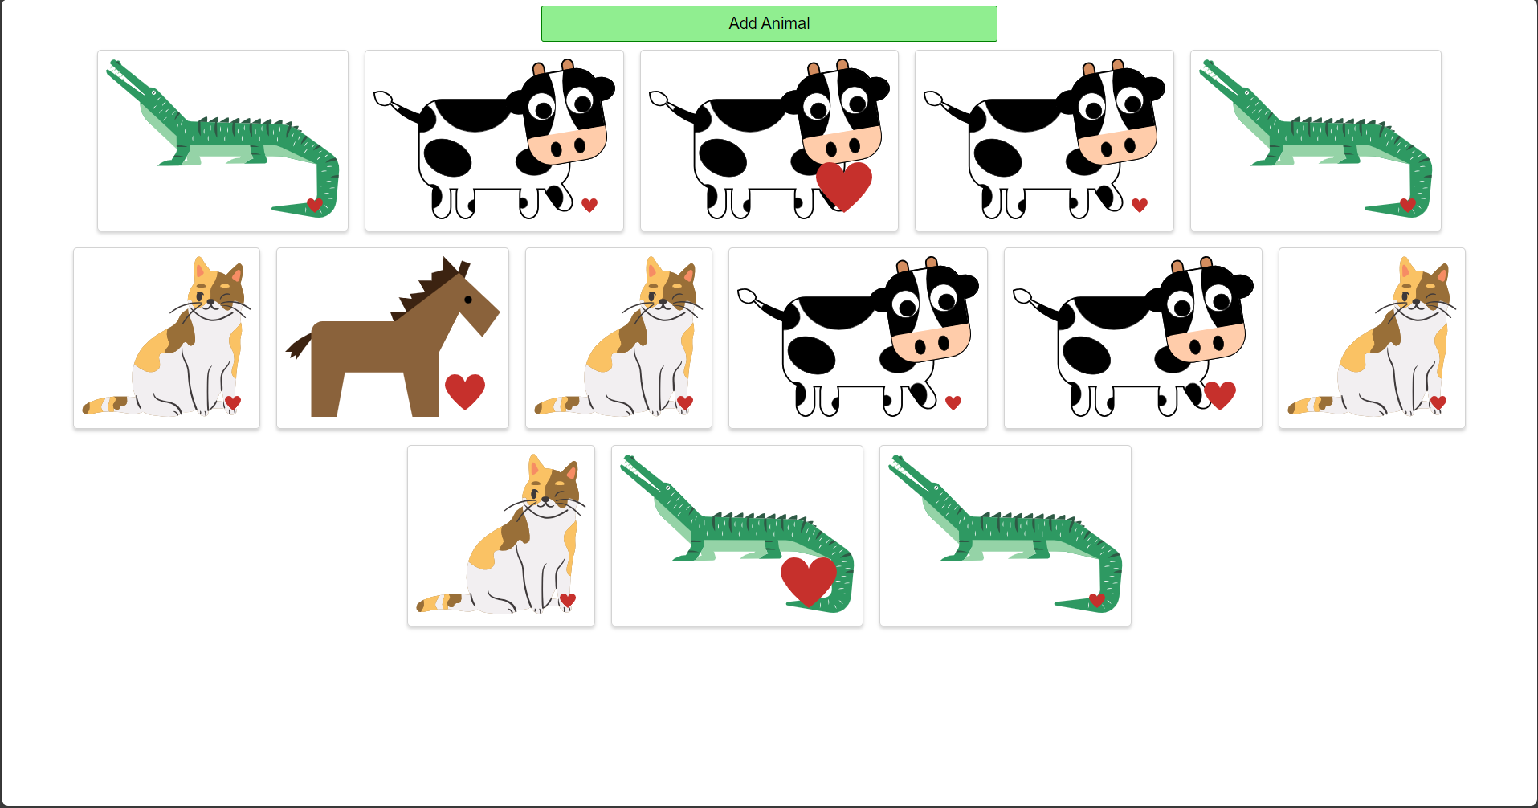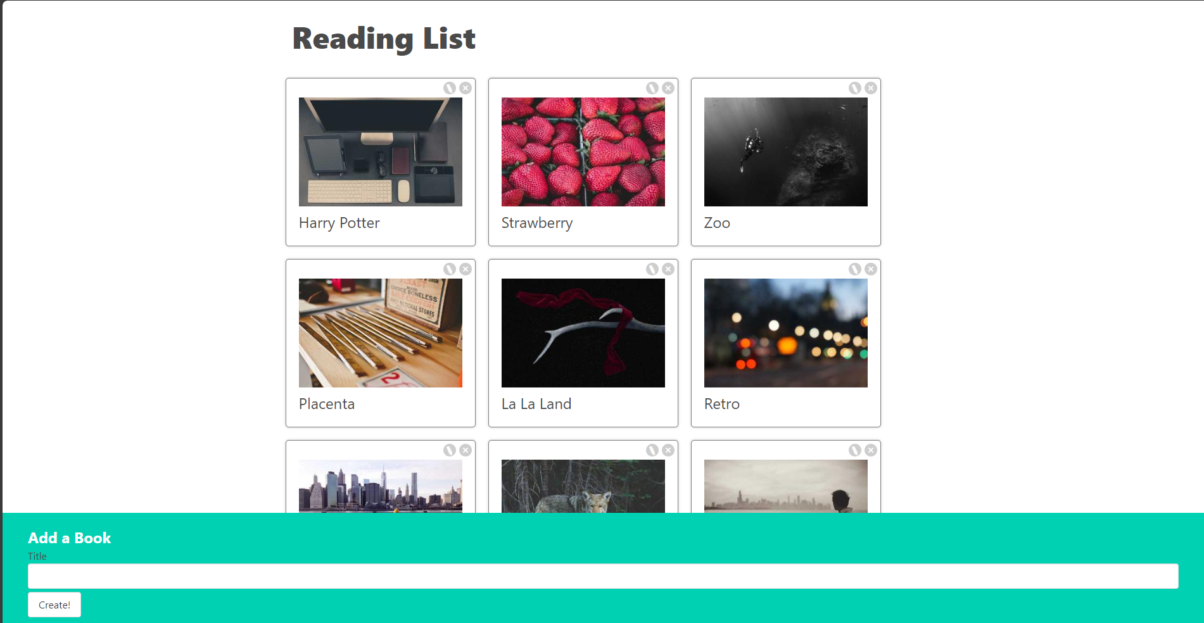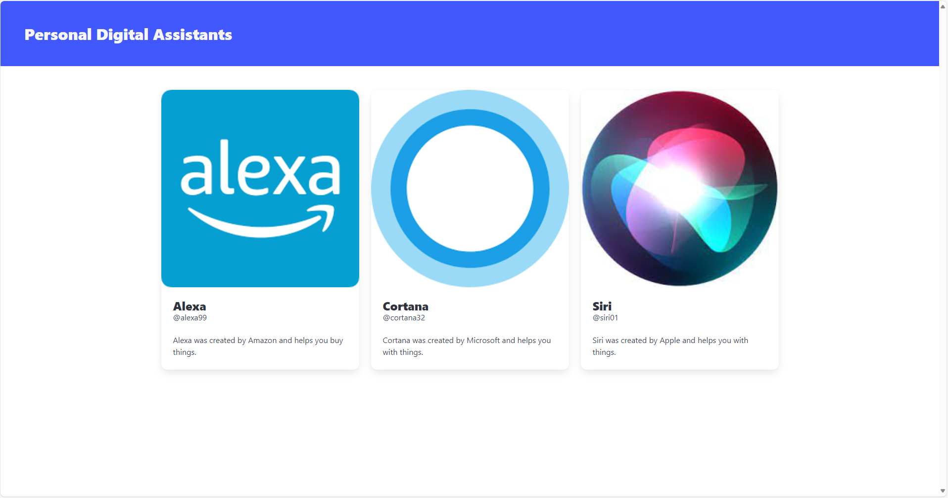

B: Microservices created during Technical Learning Path (Spring Boot)

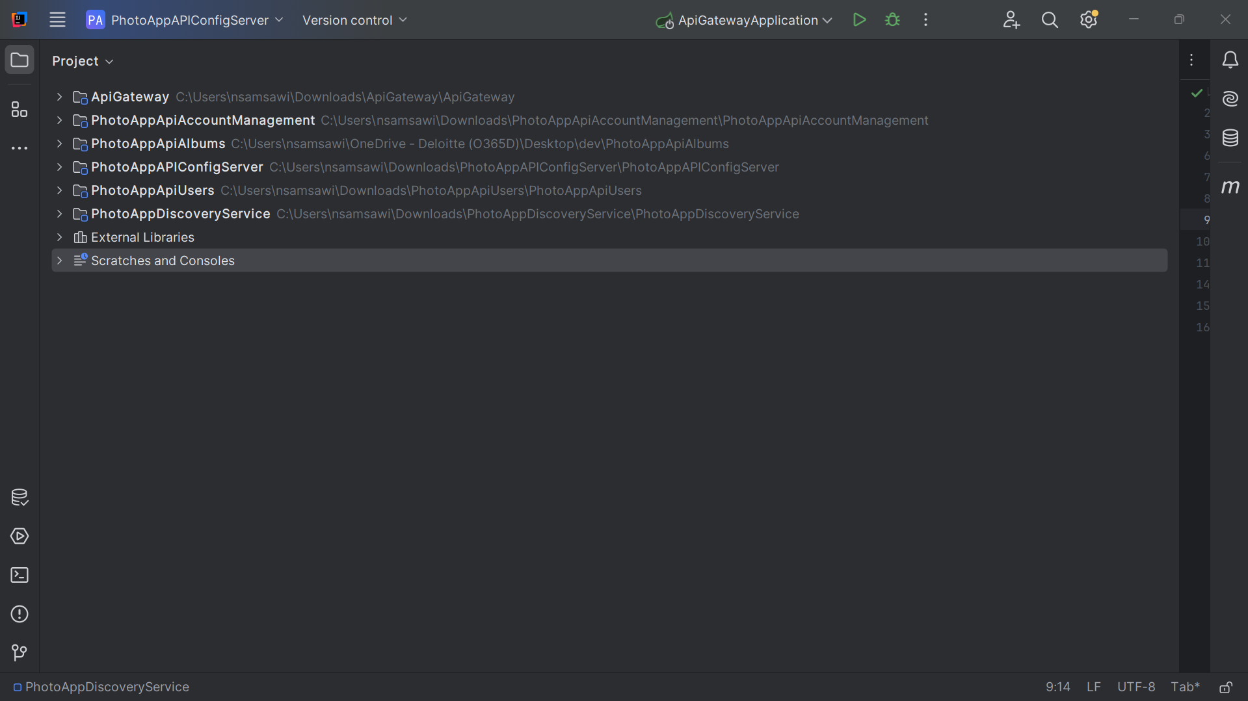

C: Interfaces of Dexter (Desktop View)

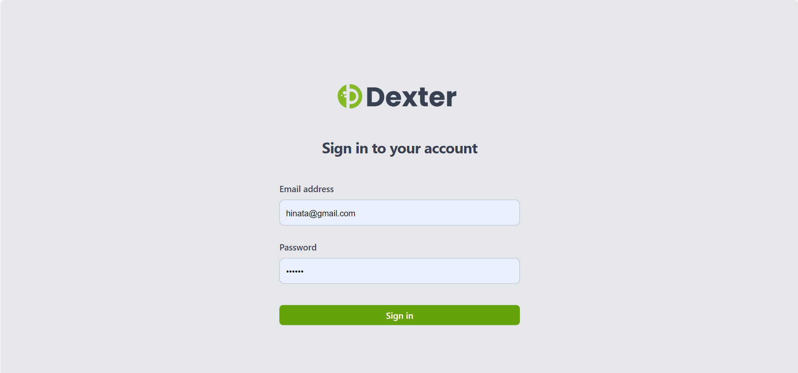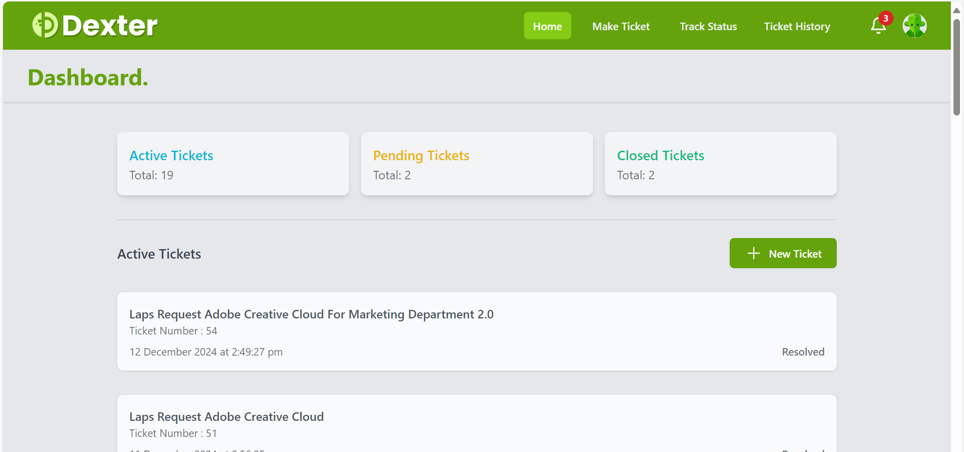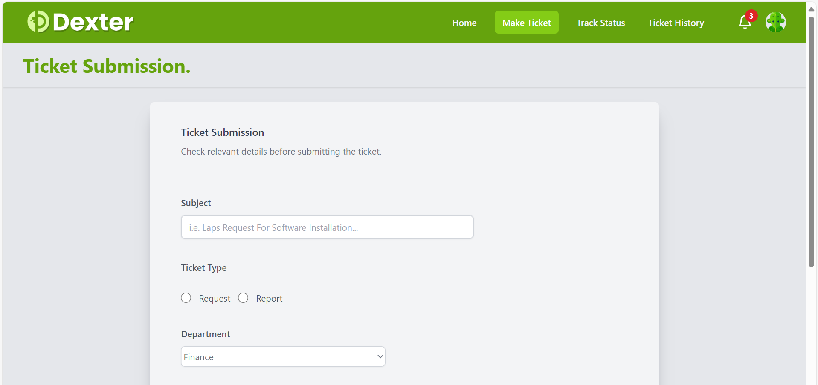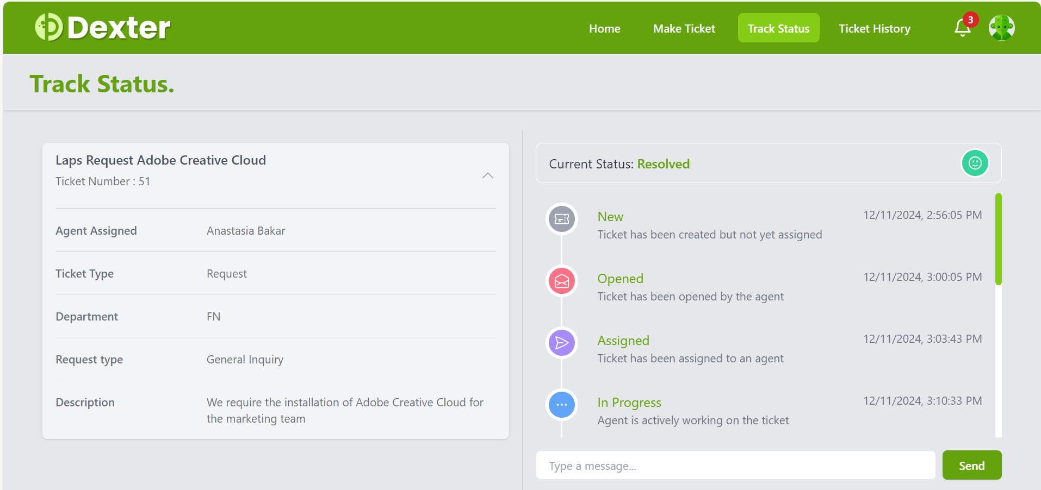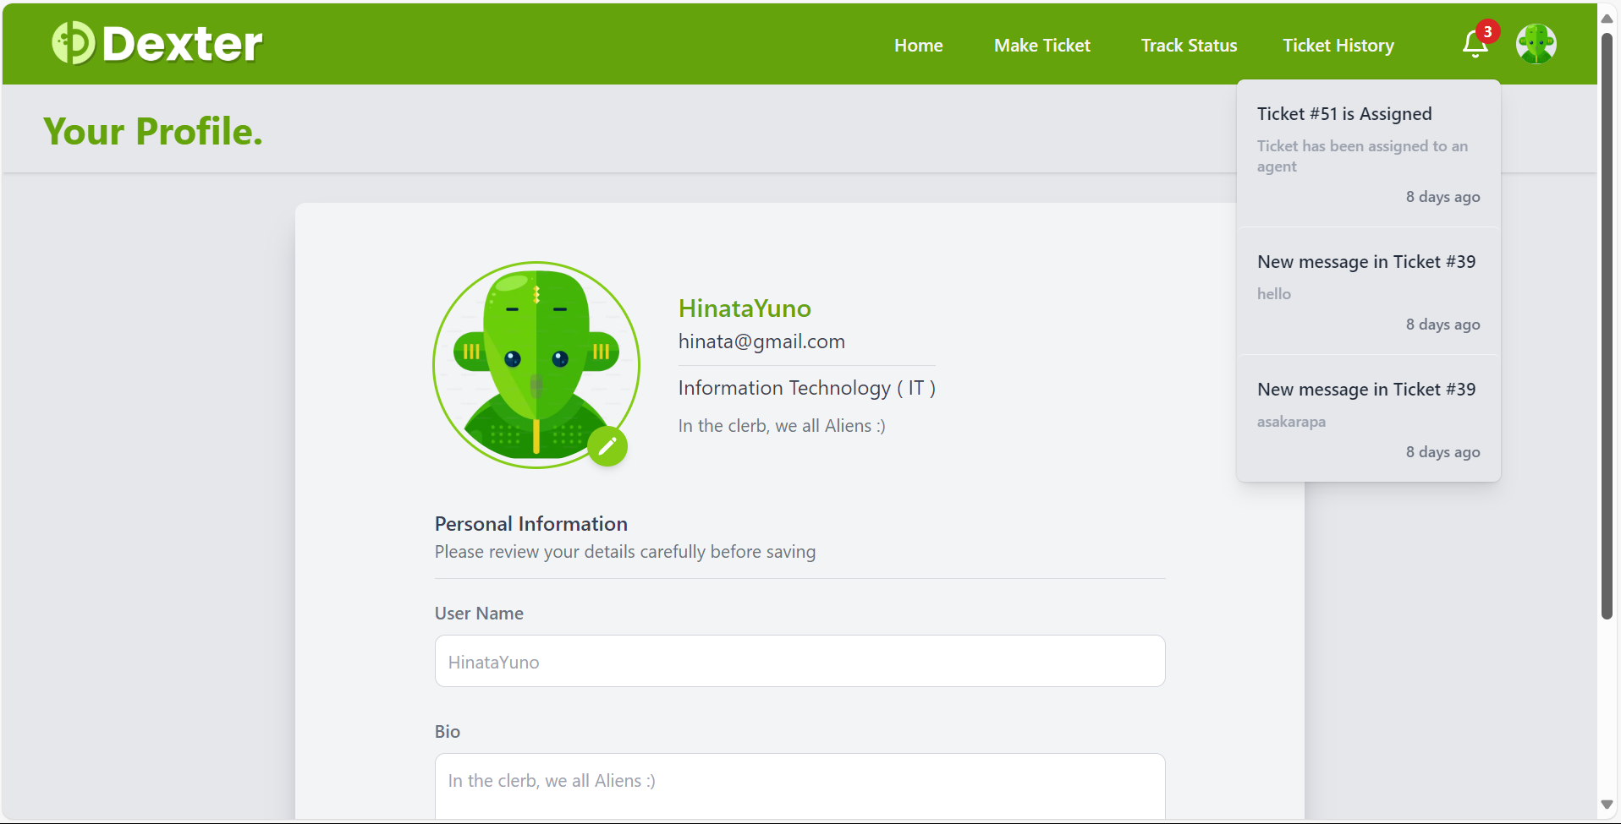

D: Interfaces of Dexter (Mobile View)

